MySQL DB systems with ORM stack

Contents

1. Introduction 3
2. Workflow diagram to deploy the stack 3
3. Create stack for MySQL DB systems 4
4. Plan the Job 7
5. Apply the Job 8
6. Verify in the Console 9
7. Destroy the stack 11

Introduction

MySQL Database is a fully-managed database service, powered by the integrated HeatWave in-memory query accelerator. It is the only cloud-native database service that combines transactions, analytics, and machine learning services into MySQL Database, delivering real-time, secure analytics without the complexity, latency, and cost of ETL duplication. It is developed, managed, and supported by the MySQL team in Oracle.
This resource provides the Mysql Db System resource in Oracle Cloud Infrastructure MySQL Database service.

Workflow diagram to deploy the stack

Below diagram shows how the Terraform Artifact are applied in the OCI. While creating a ORM stack, using terraform deliverables Init, Plan and Apply is the flow to provision the resource in the OCI. We can have the deliverables in any of below.

- GitLab/GitHub Repo
- Bitbucket
- Can be in folder/.zip in the local disk
- Object Storage Bucket
- Can be in compartment
- Oracle provided Template


Create stack for MySQL DB systems

Go to OCI Console Developer Services Resource Manager Stacks select the compartment Create Stack

My Configuration Folder Browse Select the “db_mysql” folder that contains the terraform Upload

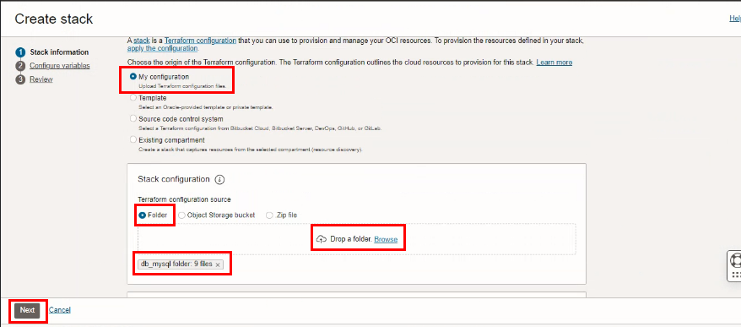

Select the parameters as per the below screen,
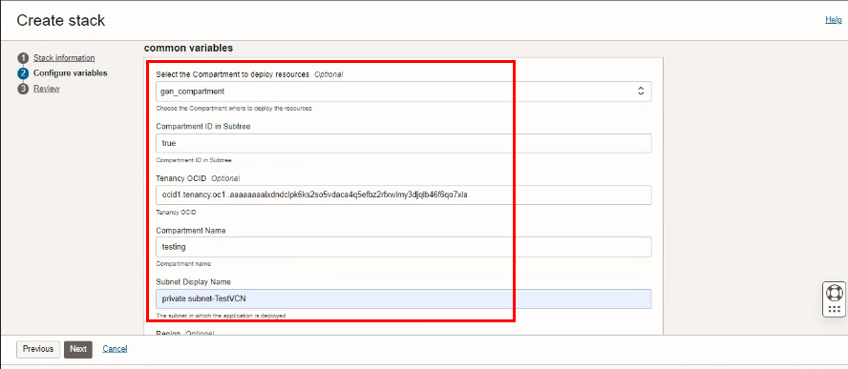

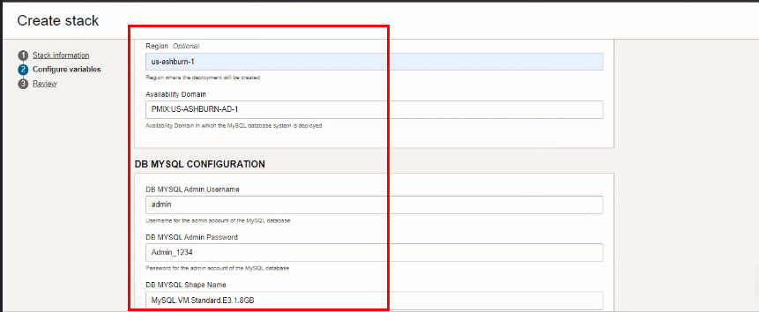

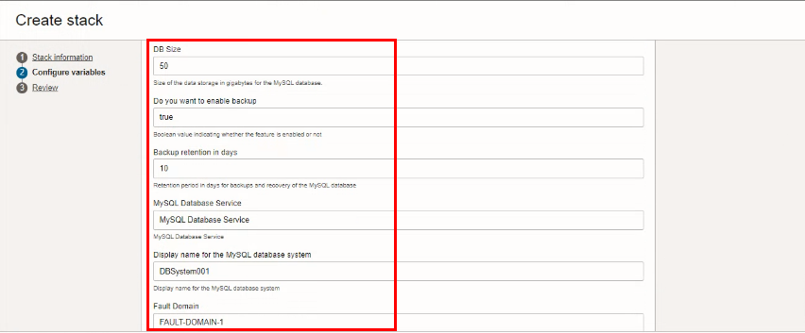

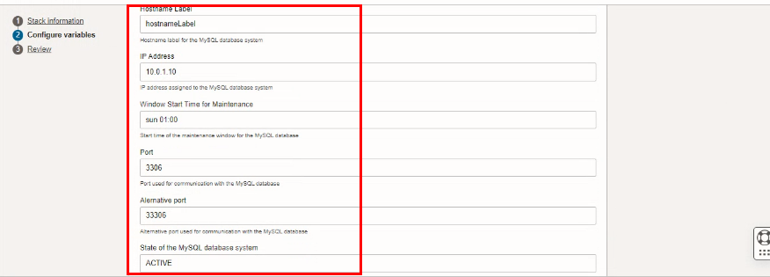

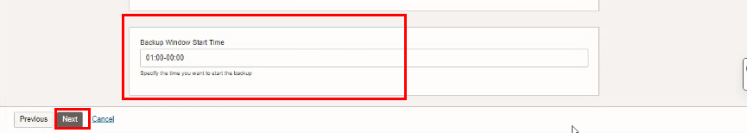

Click “NEXT”
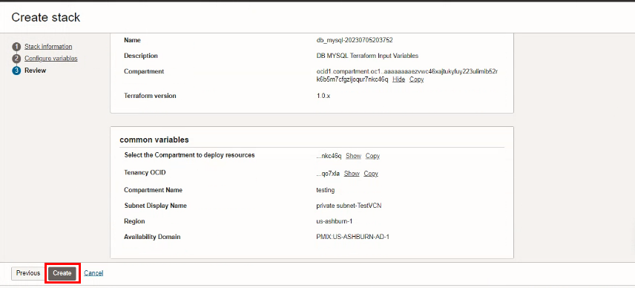
Click “CREATE”

Plan the Job

Click the “Plan”
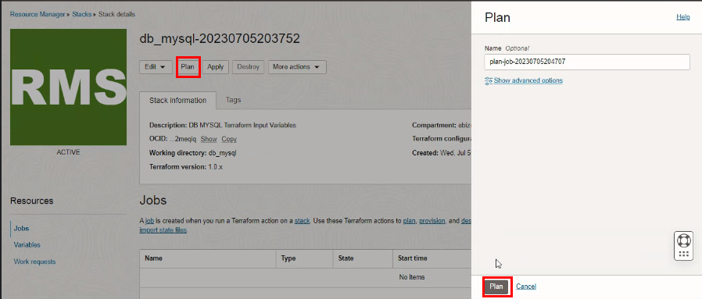
Verify the Plan is successful.
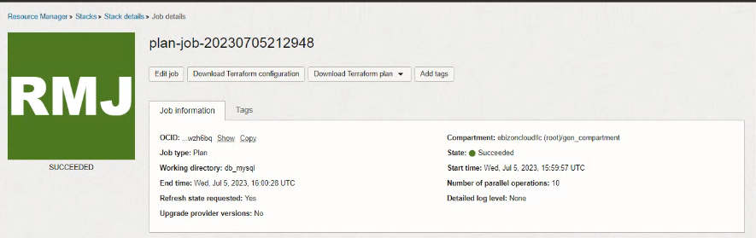
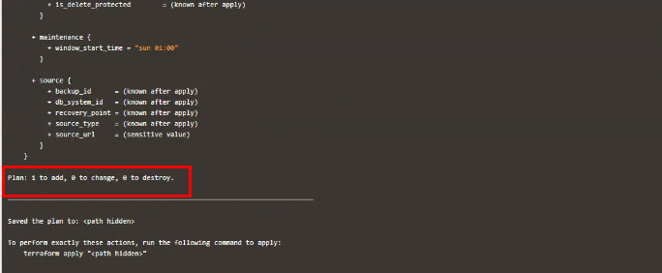

- Apply the Job

Once the “plan” is success, now click “Apply”
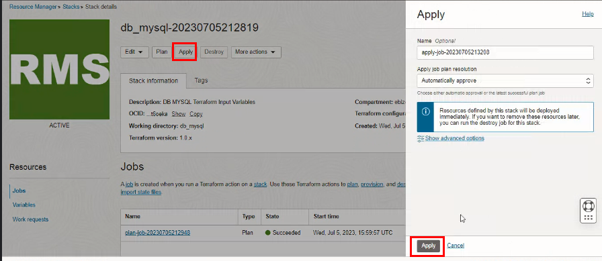

Verify the Apply is successful.
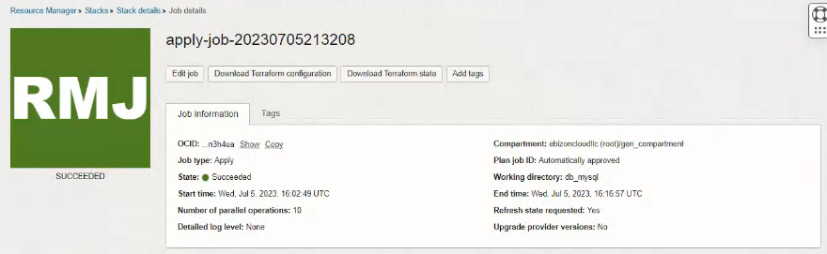

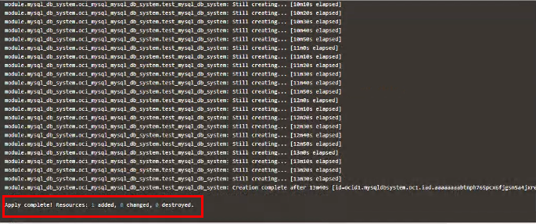

Verify in the Console

Go to OCI Console Database MYSQL DB systems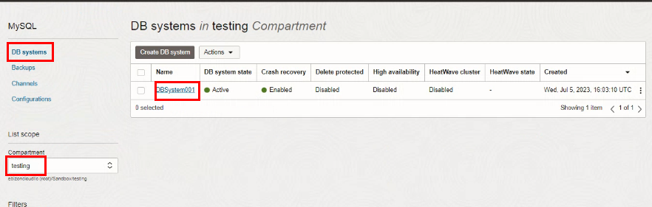
Go to OCI Console Database MYSQL DB systems DB systems details
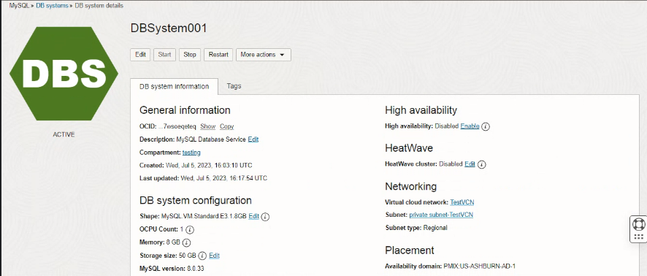

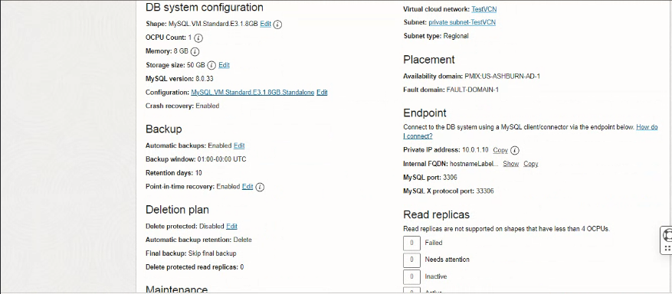

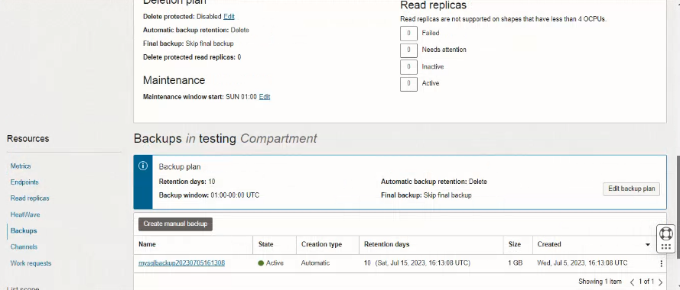

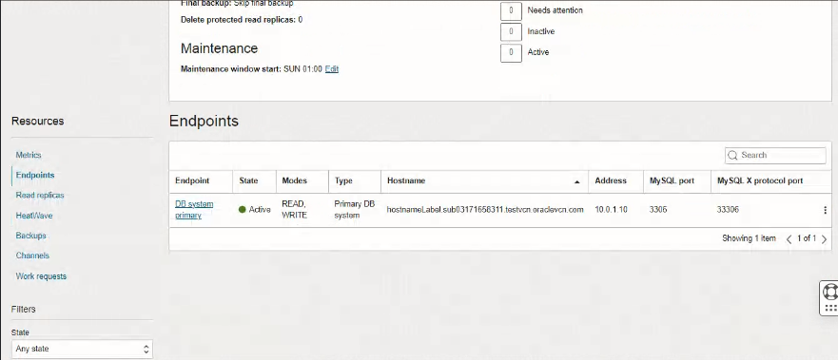

Destroy the Stack

Create a destroy job in Resource Manager to release resources associated with a stack and clean up the tenancy. Once destroyed data cannot be recovered from resources.
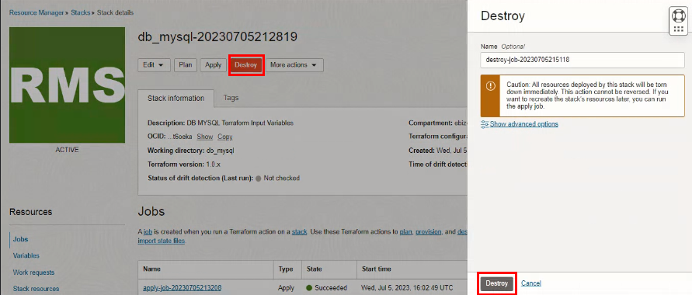

#END#

